# 

**Social Media Guide**

Guidance for Tees Valley Healthwatch Network

Growing Older Planning Ahead Project

**Table of Contents**

1

Facebook, Instagram, or Twitter 3

Carers - Carers Survey 3

Cared For Person - Cared For Person Survey 3

Professionals - Professionals Survey 3

Social Media Cards: 4

Example Graphics 4

Stakeholder Briefing 6

# Facebook, Instagram, or Twitter

## Carers - [Carers Survey](https://www.smartsurvey.co.uk/s/GrowingOlderPlanningAheadCarers/)

### Examples of posts:

1. We would like to know what the needs are of those aged 40+ with a learning disability. Your voice matters: *Survey link*
2. What would make the transition easier as people with a learning disability get older? What does good support look like? Survey link
3. What has been your experience of health and social care services as a carer of a person with a learning disability? Your voice matters: *Survey link*
4. What can be done to ensure sufficient and adequate services are in place for people with a learning disability as they grow older? What does good support look like? *Survey link*

## **Cared For Person -** [Cared For Person Survey](https://www.smartsurvey.co.uk/s/GrowingOlderPlanningAheadCaredForPerson/)

### Examples of posts:

1. As you get older, we want to know what you might need to help you. Your voice matters: *Survey link*
2. We would like to know what help you might need if you get a place of your own.   Your voice matters: *Survey link*
3. It is important that services know what this looks like and how it feels for you. Your voice matters: *Survey link*
4. Telling us what is important to you will help people decide what they need to do to help you. Your voice matters: *Survey link*

## **Professionals** - [Professionals Survey](https://www.smartsurvey.co.uk/s/GrowingOlderPlanningAheadProfessionals/)

### Examples of posts:

1. As a professional, we would like to know what the needs are of those aged 40+ with a learning disability. What does good support look like? *Survey link*
2. What would make the transition easier as people with a learning disability get older? *Survey link*
3. What currently works well, and what could be improved.? *Survey link*
4. We want to ensure sufficient and adequate services are in place for those with more complex needs. Your voice matters: *Survey link*
5. It is important that services know what this looks like and how it feels for individuals going through the process. *Survey link*
6. Your views will help us to understand the baseline of what local help is available now and what you think could be improved. *Survey link*

Possible hashtags: #learningdisability #ldcarers #ldgrowingolder

# Social Media Cards:

## Example Graphics

The example graphic can be used as it is or if you prefer to add your own local Healthwatch logo please visit Brand Stencil to recreate: [www.healthwatch.brandstencil.com](http://www.healthwatch.brandstencil.com)

For adding photos to your website we use the photo sized (800x533) which can be downloaded from Healthwatch England’s Flickr Album:

<https://www.flickr.com/photos/132747812@N04/albums/>

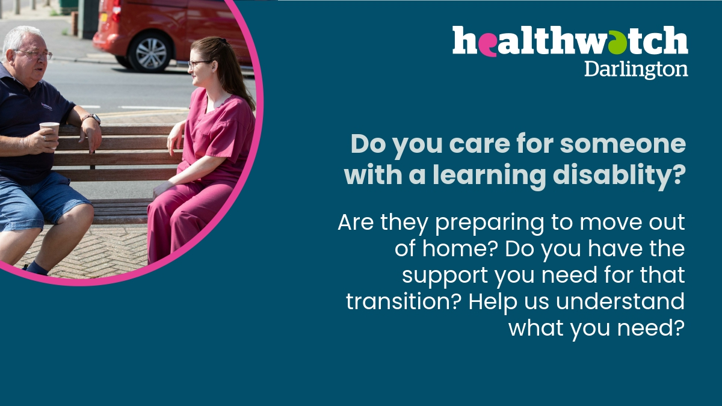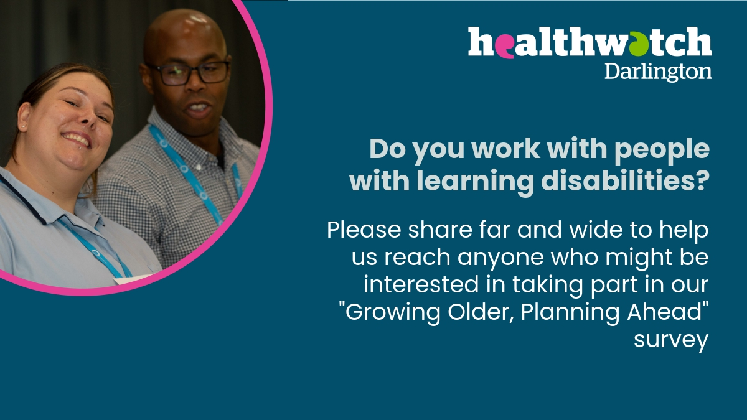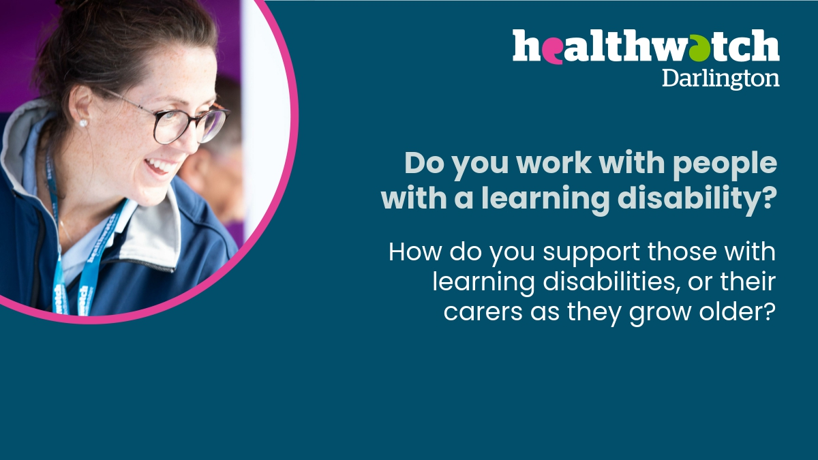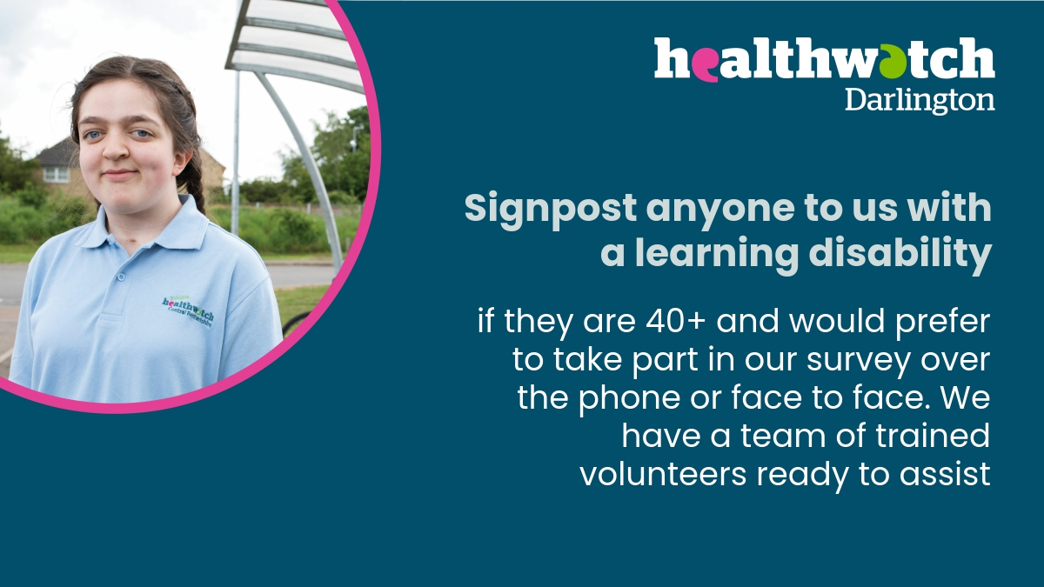

# Stakeholder Briefing

Copy and paste below logo up and insert your own details to send to VCSE and other stakeholders via email attachments for their newsletters, website, etc:

**STAKEHOLDER BRIEFING**

Adults with a learning disability and those supporting people who have a learning disability (paid and unpaid carers), and health and social care professionals.

**Healthwatch is the independent champion for people who use health and care services. We find out what people like about services, and what could be improved, and we share these views with those with the authority to make change happen.**

In the Tees Valley there are 5 Healthwatch organisations:

* Healthwatch Darlington
* Healthwatch Hartlepool
* Healthwatch Middlesbrough (Healthwatch South Tees)
* Healthwatch Redcar and Cleveland (Healthwatch South Tees)
* Healthwatch Stockton

We are working together in partnership with the North East and Cumbria NHS Integrated Care Board (NENC ICB) to identify what is needed to improve the planning process for when families can no longer support their family member to stay at home.

We would like to know what the needs are of those aged 40+ with a learning disability, what would make the transition easier as those people get older, what currently works well, and what could be improved. We want to ensure sufficient and adequate services are in place for those with more complex needs.

It’s really important that you tell us your views and experiences so we can help local providers and partnerships understand what you need so you have greater choice and control over your care and be supported to live well in your community.

We will will be holding focus groups, interviews and surveys with cared for people, carers and professionals. We will always make sure that your information is protected and treated securely.

### How can you get involved and support this project?

* + **Signpost** anyone to us who would prefer to take part in our survey over the phone or face to face. We have a team of trained volunteers ready to assist.
  + **Get in touch** if you know a looked after person, carer or professional who would like to take part in a focus group with some of our team.
  + **Share** with your networks**,** in your newsletter, on your website, or any other communications to help us reach anyone who would be interested in taking part.
  + **Share** on social media – you can share our survey links using the links below

**Please note** the surveys can be accessed directly using these links:

[Carers](https://www.smartsurvey.co.uk/s/GrowingOlderPlanningAheadCarers/)

[Cared for Person](https://www.smartsurvey.co.uk/s/GrowingOlderPlanningAheadCaredForPerson/)

[Professionals](https://www.smartsurvey.co.uk/s/GrowingOlderPlanningAheadProfessionals/)

Easy read available too.

**Contact us**: Healthwatch South Tees (Healthwatch Middlesbrough & Healthwatch Redcar and Cleveland) , Tel.No: 0800 118 1691, Text: 07451 288789,

Email: healthwatchsouthtees@pcp.uk.net